Flag of Tibet
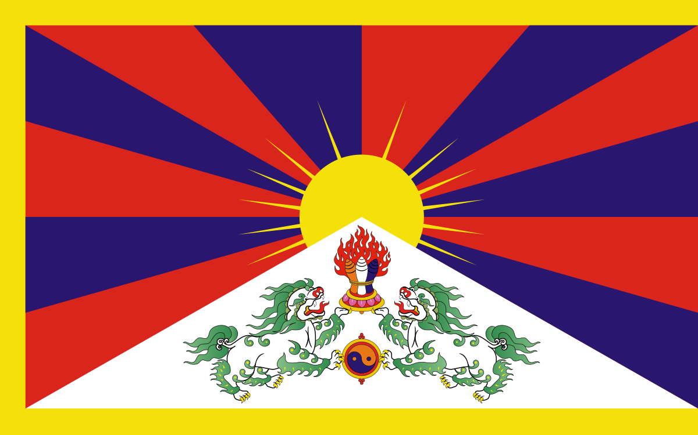
The turning point of Tibet's history came in 1949, when the People's Liberation Army of the PRC first crossed into Tibet. After defeating the small Tibetan army and occupying half the country, the Chinese government imposed the so-called "17-Point Agreement for the Peaceful Liberation of Tibet" on the Tibetan government in May 1951. Because it was singed under duress, the agreement lacked validity under international law. The presence of 40,000 troops in Tibet, the threat of an immediate occupation of Lhasa, and the prospect of the total obliteration of the Tibetan state left Tibetans little choice.
As the resistance to the Chinese occupation escalated, particularly in Eastern Tibet, the Chinese repression, which included the destruction of religious buildings and the imprisonment of monks and other community leaders, increased dramatically. By 1959, popular uprising culminated in massive demonstrations in Lhasa. By the time China crushed the uprising, 87,000 Tibetans were dead in the Lhasa region alone, and the Dalai Lama had fled to India, where he now heads the Tibetan Government-in-exile, headquartered in Dharmsala, India. In 1963, the Dalai Lama promulgated a constitution for a democratic Tibet. It has been successfully implemented, to the extent possible, by the Government-in-exile.
Meanwhile, in Tibet religious persecution, consistent violations of human rights, and the wholesale destruction of religious and historic buildings by the occupying authorities have not succeeded in destroying the spirit of the Tibetan people to resist the destruction of the national identity. 1.2 million Tibetans have lost their lives, (over one-sixth of the population) as a result of the Chinese occupation. But the new generation of Tibetans seems just as determined to regain the country's independence as the older generation was.
For more information click HERE

