Tibet
Land of Mystery, Enchantment, and Mythology – “Land of Bod”

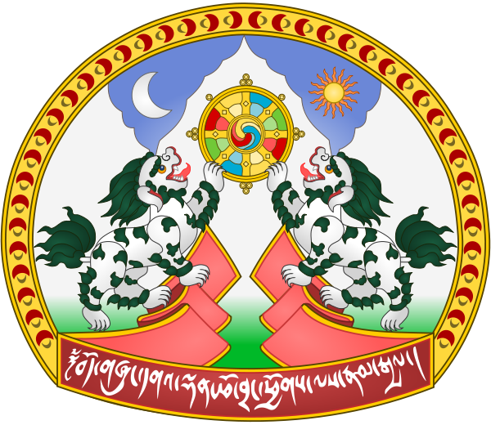

If you made a visit to Tibet, if it was before the Chines invasion and if your first stop after your arrival was to a Tibetan Visitor’s Center, then the greeters at this visitor’s center would greet you at the door by saying, “Welcome to the “Land of Bod.” The land of Bod is the country we call Tibet, or The Land of Snow, and is the highest nation, with the highest mountains, on earth with an average elevation of 14000 feet. Tibet lies in the shadow of the vast Chinese empire and is sandwiched between the Himalayas to the South and the Kunlun Mountains to the North; however, the country of Tibet no longer exists on the maps of the world because the Chinese consider Tibet to be just another province of the mainland.

In addition to having the highest mountains in the world, five of Asia’s great rivers, two of which are the Indus and the Mekong, have their headwaters in Tibet. What is truly amazing about this fact is that nearly half the world’s population lives downstream from Tibet, and although it may be hard to imagine, the plateau of Tibet means life to most of Asia. Should that water be diverted, or contaminated, Asia would die a slow death.

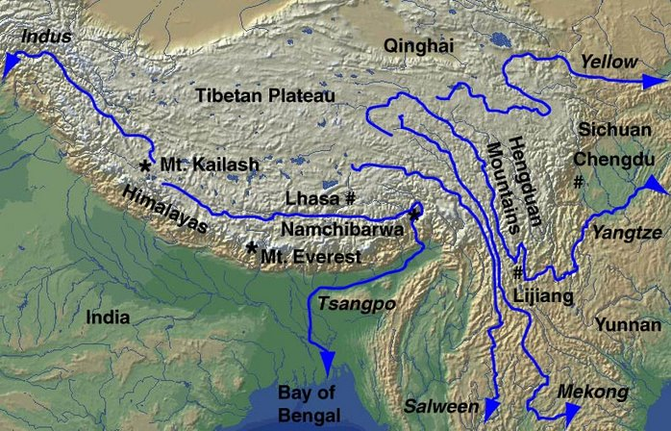

(Rivers of Tibet)
Most of the northern and western parts of Tibet are barren deserts with wind-blown sand dunes crusted with salt. The Northeast consists of grassy plains with few inhabitants, other than nomadic herdsmen, and the Southeast has well-defined mountains with narrow valleys. It is in the Southeast area that you will find terraced agricultural plots, pastureland, and a large part of the country’s population.

For more information click HERE

