The Dali Lama

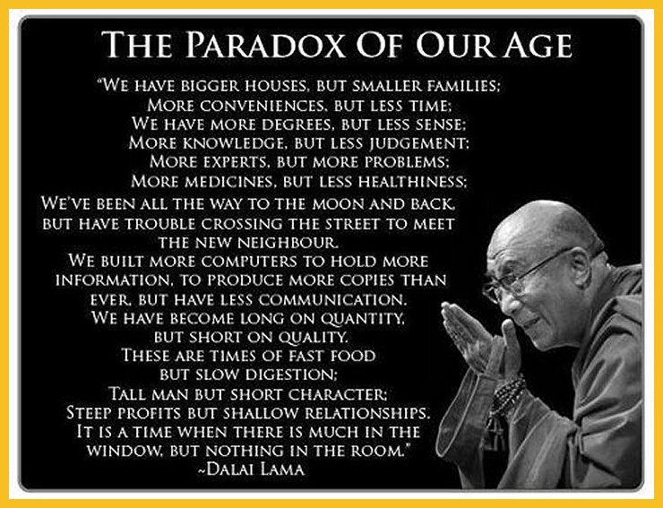

I think most of us have seen on TV, or read in the news, something about the Dali Lama and his role in modern day life. However, to understand who the Dali Lama is, and what he stands for, you need a basic understanding of the religion he represents – Buddhism.

Buddhism has a following of around 400 million people and the word itself comes from “Budhi” which means to awaken. It has its origins about 2500 years ago when the man we all know as Buddha, his real name is Siddharta Gotama and is pronounced Si-dar-ta- Gaw-ta-ma, was awakened, or enlightened, at the age of 35.

Buddha was born in to a royal family in Lumbini, which is located in Nepal. At the age of 29 he realized that wealth, and personal luxury, does not guarantee happiness so he began to explore the different teachings, and philosophies, found in the different religions of the day. Six years after his quest began Buddha found what a Buddhist refers to as the “Middle Path “and was enlightened. After his enlightenment, Buddha spent the rest of his life teaching the principles of Buddhism, which is called the Dharmma, or truth, and taught until his death at the age of 80.

Now, before we continue I have a personal viewpoint that I would like to share with you. I am not a deeply religious person, but I am a believer in a supreme being, or universal power source as some would say; however, in my readings of Buddha’s teachings there is one quote that has special value to me personally. It reads as follows:

“Believe nothing, no matter where you read it, no
matter who said it, no matter if even I said it,
unless it agrees with your own reason and your
own common sense.”

There are not many religious, or political, leaders in today’s world that would be so bold as to go on the record with such a strong testament of faith. Buddha did, and I would suggest to all who read this to use these words as a guide in your daily life when considering the words of your chosen political or religious leader.

For more information click HERE

