The Panchen Lama is one of the most important figures in Tibetan Buddhism, second only to the Dalai Lama himself. Perhaps his most important job is the role he plays in recognising the next reincarnation of the Dalai Lama, who then in turn finds the reincarnated Panchen Lama. This tradition has endured for centuries.
The previous Panchen Lama (Lobsang Trinley Lhundrup Choekyi Gyaltsen) spoke out against Chinese rule many times and wrote a report chronicling Tibet's famines in the 1960s. As a result, he spent more than eight years in jail and died in suspicious circumstances in 1989.
In 1995 a list of possible candidates for the next Panchen Lama was sent to the Dalai Lama (living in exile in India), and on 15 May he announced that Gedhun had been recognised as the 11th Panchen Lama. Two days later, the Chinese government abducted the child and his family. None of them have ever been seen or heard from again.
For more information click HERE
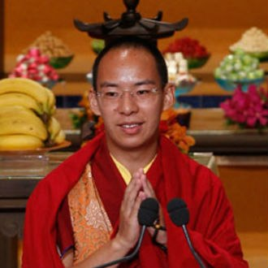

Why was he kidnapped?

