The Tibetan Massacre
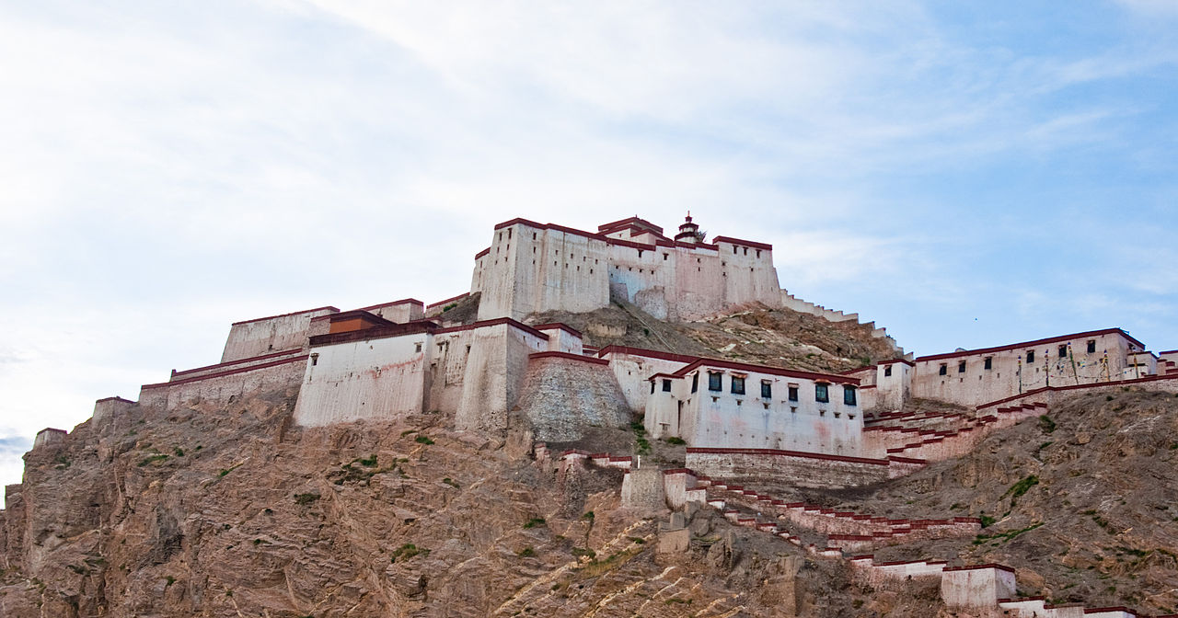

“Cultures of memory are organized by round numbers, intervals of ten; but somehow the remembrance of the dead is easier when the numbers are not round, when the final digit is not a zero … [I]t is perhaps easier to think of 780,863 different people at Treblinka: where the three at the end might be Tamara and Itta Willenberg, whose clothes clung together after they were gassed, and Ruth Dorfman, who was able to cry with the man who cut her hair before she entered the gas chamber … Each of the 21,892 Polish prisoners of war shot by the NKVD in 1940 was in the midst of life. The two at the end might be Dobiesław Jakubowicz, the father who dreamed about his daughter, and Adam Solski, the husband who wrote of his wedding ring on the day that the bullet entered his brain. The Nazi and Soviet regimes turned people into numbers, some of which we can only estimate, some of which we can reconstruct with fair precision. It is for us as scholars to seek these numbers and to put them into perspective. It is for us as humanists to turn the numbers back into people. If we cannot do that, then Hitler and Stalin have shaped not only our world, but our humanity.”

The passage above—it comes at the conclusion of Bloodlands— is worth bearing in mind, for it helps to restrain the cynical temptations of the sentiment (apocryphally attributed to Stalin) that while the death of one person might be a tragedy, the deaths of millions is a mere statistic. Ironically, that sentiment sometimes seems to have had greater sway among some of those concerned about Tibet’s modern fate than one might think, perhaps because the figure that the Tibetan political leadership adopted in the 1980s, 1.2 million Tibetan deaths over two to three decades (rounded down from a rougher, albeit little mentioned number), is the figure that is almost always cited. It is an anesthetizing number and it stands in spite of the fact that it was reached on the basis of the most unreliable and anecdotal methodology. Indeed, it has been hard for any but the most uninformed partisans of the Tibetan cause to grant any credence to the number; more objective observers (including many who are unabashedly sympathetic to Tibet) have rejected it. The 1.2 million figure was largely derived from estimates made as a result of the first visits of Tibetan delegations from Dharamsala to Tibet beginning in 1979, particularly the first delegation, as well as interviews with Tibetans coming into exile. No one involved in the delegation visits had any demographic training, but more to the point, given the difficulties inherent in counting living people in a country to which one has full access, the impossibility of accurately counting—with or without the requisite training—the deceased over a period of several decades in a country to which one has highly limited access should have been obvious to all.
I mention this not to downplay the extent of the slaughter in Tibet (and let’s not mince words about what happened) but simply to posit that one cannot simply assign a figure without any serious attempt to establish a basis for it. To do so is to bring oneself to the point at which a million deaths do congeal into a mere statistic. Should the 1.2 million figure then be dismissed? Yes, not because something horrible did not transpire on the Tibetan Plateau, but because it has no reliable foundation. It is beyond dispute that there have been massive deaths in Tibet in the period between approximately 1950 and 1975. But 1.2 million? It is currently impossible to say. And by that I mean that while the actual number of deaths might be much less, it would still have to be very considerable. One simply cannot know the exact number without free access to Chinese records. But the fact that a large-scale slaughter took place ought to be unquestioned.
The matter of mass death in Tibet has rarely been raised within the PRC, at least officially, and then, only to rebut claims of such an occurrence. And for a number of years one has seen scant reference to it in official exile statements, perhaps partly a result of the United Front Work Department injunction several years ago (passed on, as we now know, directly to Lodi Gyari and ultimately enunciated by the Dalai Lama) that Tibetans must do nothing to embarrass the Chinese Government. (The degree of obsequiousness inherent in this is indeed revelatory.) But the traces of history don’t always comply with the wishes of the political class.
For more information click HERE

